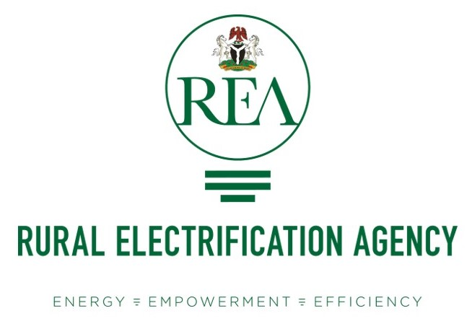

RURAL ELECTRIFICATION AGENCY
CALL FOR RESEARCH
Template for Concept Note

Table of Contents
About Rural Electrification Agency 3
Research and Innovation Call for Proposal Overview 4
Guidelines for Preparation of a Concept Note 5
Acronyms 7
List of Figures 8
Project Summary Sheet 9
Abstract 10
Literature Review
Proposed Research Methodology
Research Policy Relevance
Expected Outputs
Anticipated Impact
Budget/Cost Information
Research Timeline
References

About Rural Electrification Agency
The Rural Electrification Agency (REA) of Nigeria is mandated to promote and provide electricity to rural and underserved communities across the country. The key objectives of REA’s mandate include:
- Increase Access to Electricity in unserved rural areas which includes extending grid connections to off-grid areas and supporting the development of decentralized energy systems such as mini-grids and solar home systems.
- Promotion of Renewable Energy and Technologies, such as solar, wind, and biomass, to provide sustainable and environmentally friendly power solutions for rural communities. This is crucial in areas where conventional grid electricity is expensive or technically difficult to deliver.
- Supporting Off-Grid Electrification through solar mini-grids, solar home systems, and other decentralized energy systems. The agency seeks to electrify communities that are too remote to be connected to the national grid.
- Promotion of partnerships with private sector investors, international development organizations, and local communities to enhance the financing and implementation of rural electrification projects.
- Increase Economic Growth and Development by providing electricity access to rural communities to spur economic growth, improve livelihoods, create jobs, and enhance social services such as healthcare and education in these areas.
- Promotion of Gender Equality and Inclusion: through gender-sensitive approaches by incorporating the unique energy needs of women and marginalized groups in rural communities.
- Environmental Protection and Sustainability by aligning projects with environmental sustainability goals, promoting clean energy solutions that reduce carbon emissions and support Nigeria’s climate change commitments.
Through these objectives, REA's mandate is to provide universal access to affordable and sustainable electricity in rural Nigeria, improving the quality of life and enabling socio-economic development.
Research and Innovation Call for Proposals Overview
grant amount: Up to Two (2) Million Naira
objective: To support research and innovation that addresses critical challenges and promotes development in specific sectors, such as energy, agriculture, technology, or social sciences.
Key Focus Areas
- Innovative and Sustainable Renewable Energy Technologies
- Rural e-Mobility
- Electric Motor-driven Mills:
- Energy Efficiency in Productive Uses (PU) Improvement

- Investment & Funding of Sustainable Renewable Energy in Rural Areas
- Mobilisation of Renewable Energy Investment

- Advances in Off-Grid / Stand-Alone Renewable Energy Systems
- Trends and advances on the improvement of renewable energy equipment

- Smart Utility Management and Security
- Metering & Remote Monitoring
- Smart Mini-grids
- Energy Security and Protection

- Business Models and Policy Impact Assessment for Decentralised Mini-grids
- Business Concepts & Models

- Renewable Fuel Power Production
- Solar
- Biomass
- Hydro
- Energy Mix
7 Programmes Impact Assessment: Best practices covering:
- Economic
- Environmental
- Social

Concept Note:
- This Concept Note outlines the structure for the research proposal, which is submitted by individual researchers or research group as a basis for seeking funding.
- This is to allow researchers to submit their research proposal in summary form for preliminary assessment and evaluation without the need to submit completed work and to allow reviewers make quick decisions on whether concepts are suitable for further consideration.
- Concept Note should be submitted within the defined scope.
- Concept Note which do not meet the below specifications would stand no chance of being selected.
- Detailed proposal are not guarantees that the proposal will necessarily be accepted for funding.
- Concept Notes for the Rural Electrification Fund Call for Research Programme should be uploaded in the REA website: https://researchinnovation.rea.gov.ng/

Submission and Deadline:
- Proposals should be submitted electronically through a self-created account registered on https://researchinnovation.rea.gov.ng/cfr/register
- Only complete proposals following the given guidelines will be considered.

Grant Disbursement:
- Disbursement will occur in phases, tied to key project milestones.

Proposal Title:

Principal Investigator:

Name
Occupation
Address
Rank/Position
Email
Phone
Date
Team Member(s):
Occupation
Address
Rank/Position
Email
Phone
Date
1 | Occupation  Address  Rank/Position  Email  Phone  Date
2 | Occupation  Address  Rank/Position  Email  Phone  Date
3 | Occupation  Address  Rank/Position  Email  Phone  Date

Acronyms
Insert abbreviations formed from the initial letters of other words.

REA Rural Electrification Agency

List of Tables/Figures

Insert list of tables and figures with page number below
Tables
- Table 1: (Title of Table)……………………………………………………………….Page

Figures
Figure 1: (Title of Figure)…………………………………………………………….Page

PROJECT SUMMARY SHEET
PROJECT TITLE:

NAME OF PRINCIPAL INVESTIGATOR:

BRIEF ABOUT THE PRINCIPAL INVESTIGATOR:
State of Origin:
LGA:
Geo Political Zone:
Institution of Lecturing/Industry:
Field of Expertise / Specialty
Status: (Lecturer/Industry player)
LIST OF COLLABORATORS:

BREAKDOWN OF PROJECT COST (NGN): | Financial summary box below
DURATION OF PROJECT:
DATE OF SUBMISSION:

Abstract
(250 words Max)

Literature Review
- (1000 words max)

- A comprehensive summary of previous research on the proposed topic surveying scholarly articles, books, and other sources relevant to the proposed research. The review should enumerate, describe, summarize, objectively evaluate and clarify this previous research.

Proposed Research Methodology
Highlight specific procedures or techniques used to identify, select, process, and analyze information about the proposed research

Research Policy Relevance
(200 words Max)

Highlight how effectively research findings aligns with REA’s core mission and informs decisions made by decision-makers.

Expected Outputs
(500 words Max)

Anticipated Impact
(200 words Max)

Includes how the outputs will contribute towards achieving the mandate of the Rural Electrification Agency

Budget/Cost Information
Includes how the outputs will contribute towards achieving the mandate of the Rural Electrification Agency

Research Timeline
(Three Weeks)

References

